1. First of all, what is Cryptography & why do we use it?
2. Graphical user interface, text, application

   Description automatically generated
3. Let take a look at the important keywords related to Cryptography.
   1. 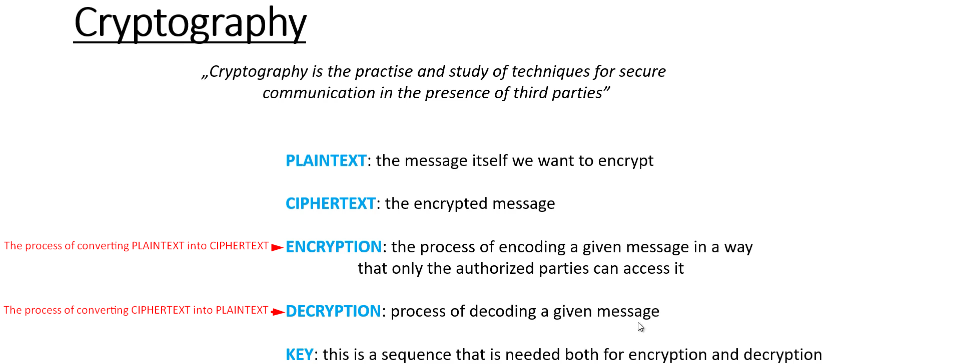
   2. Encryption & Decryption are basically mathematical functions.
   3. Graphical user interface

      Description automatically generated with low confidence